CREATE IBM WATSON IOT PLATFORM AND DEVICE

|  |  |
| --- | --- |
| **Date:** | 18 NOVEMBER 2022 |
| **Team ID:** | PNT2022TMID42163 |
| **Project Name:** | GAS LEAKAGE MONITORING AND ALERTING SYSTEM FOR INDUSTRIES |

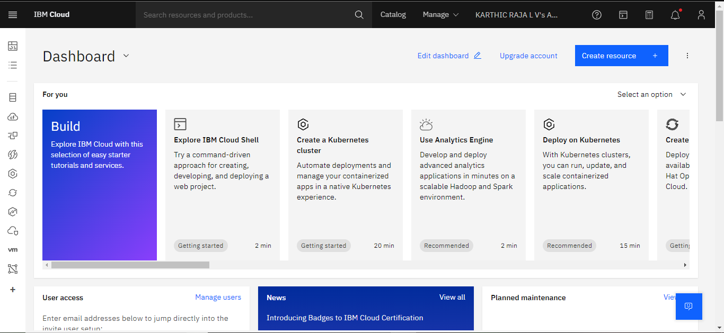

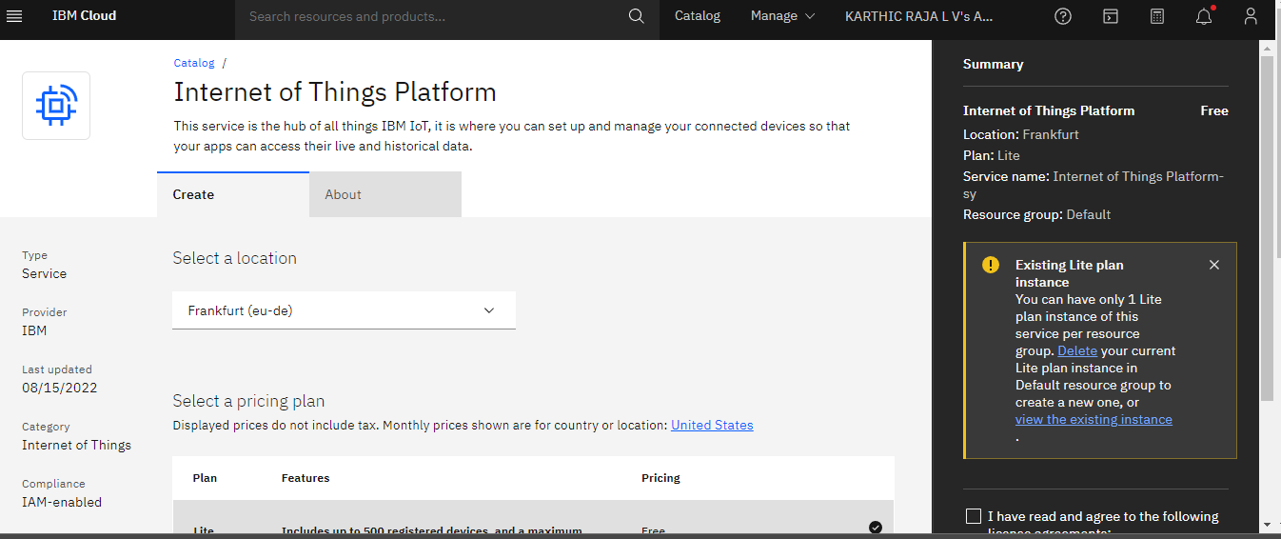

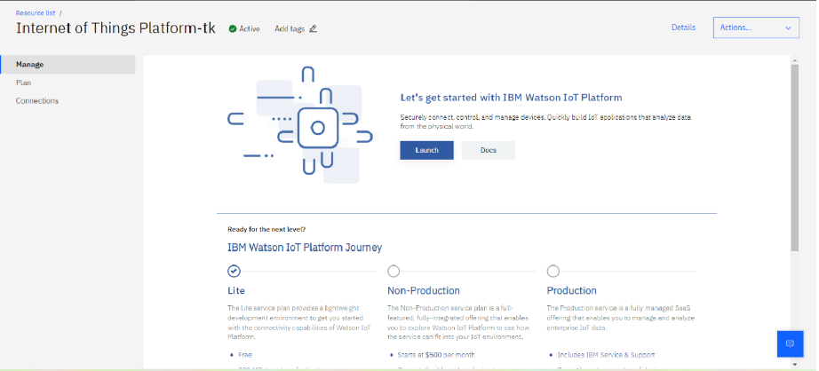

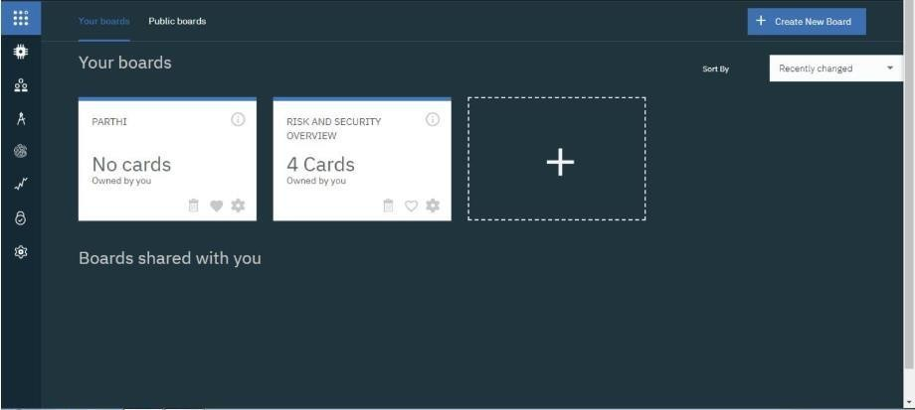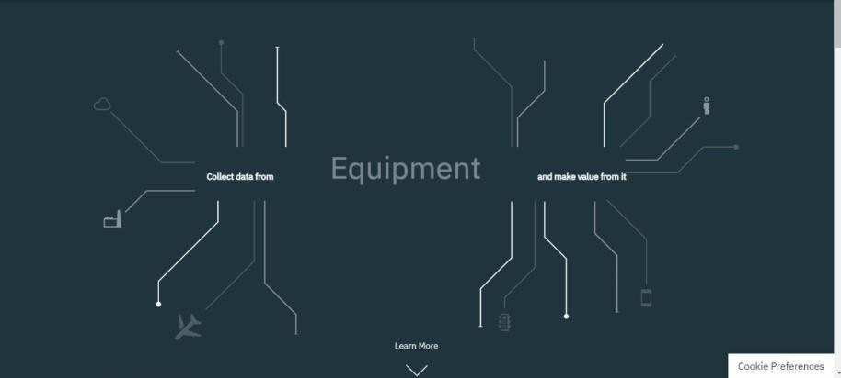

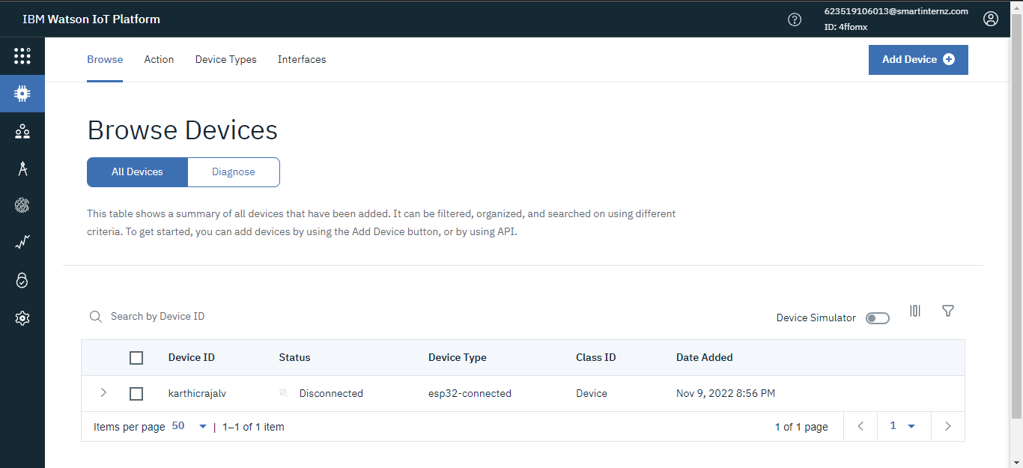

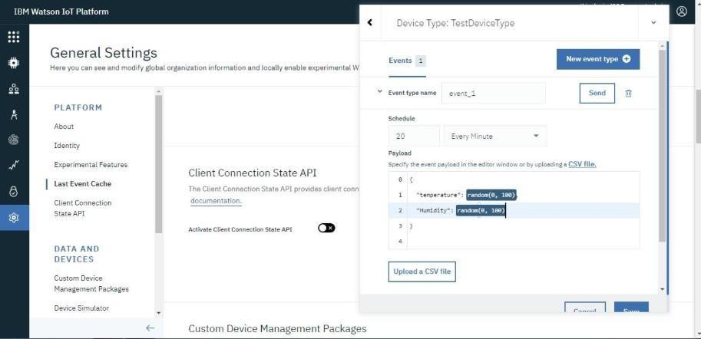

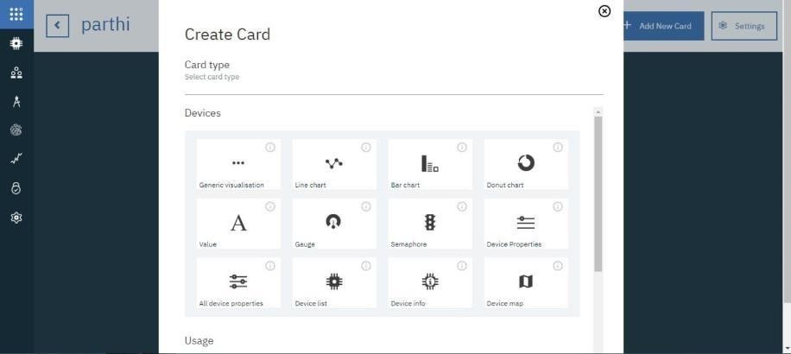

**Result:**

An IBM Watson cloud for IoT and a device is created successfully.